**Project Name: Online Primary School Finding Application**

**Assignment No.3: Prototype Phase**

**Semester: Fall 2022**

**Problem Statement for Prototype Phase:**

Develop a web based application “School Finding Application”. The users of the system are admin and user (Parent).

Admin tasks are given below:

|  |  |
| --- | --- |
| **Tasks** | Login to the system with user name and password. |
| Add the School information |
| Update the School Information. |
| Delete the School Information. |

User (Parent) tasks are given below:

|  |  |
| --- | --- |
| **Tasks** | Register himself/herself with the School Finding Application. |
| Login to the system with user name and password. |
|  | View all the school’s information. |

Following are the details of each task:

**Task 1**

There should be a table “Admin” to store Admin details (such as name, id, password, emailid, contact). Detail of table is as follows:

|  |  |
| --- | --- |
| **Column Name** | **Data Type** |
| Id [primary key] | Integer |
| Name | Varchar(50) |
| Password | Varchar(50) |
| Emailid | Varchar(100) |
| Contact | Varchar(100) |

When trying to log in, the system shall check for correct id and password. If incorrectly entered by the user, system shall show error message.

**Task 2**

1. There should be a table “User (Parent)” to store the user details such as (id, username, password, email, contact). Detail of table is as follow:
2. The columns and data types of these columns shall be:

**User (parent)**

|  |  |
| --- | --- |
| **Column Name** | **Data Type** |
| User_id [primary key] | Integer |
| UserName | Varchar(50) |
| Password | Varchar(50) |
| Email | Varchar(100) |
| Contact | Varchar(100) |

**Task 3**

1. There should be a table “School” to store the school details such as (SchoolId, SchoolName, Address, SchoolPicture). Detail of table is as follow:

**School**

|  |  |
| --- | --- |
| **Column Name** | **Data Type** |
| Schoolid | Select any appropriate data type |
| SchoolName, | Select any appropriate data type |
| Address | Select any appropriate data type |
| SchoolPicture | Select any appropriate data type |

**Task 4**

You have to design the main interface as per the following sample screen shot.

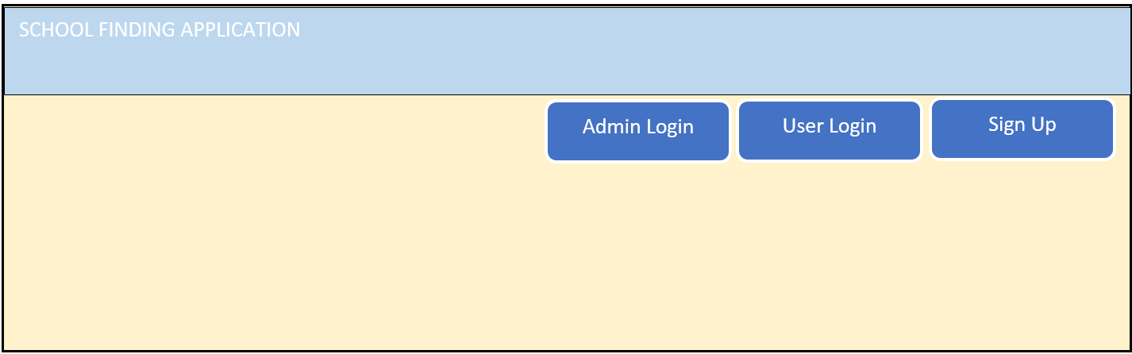

**Task 5**

When the Admin click on the Admin Login tab/button, the following sample screen appears:

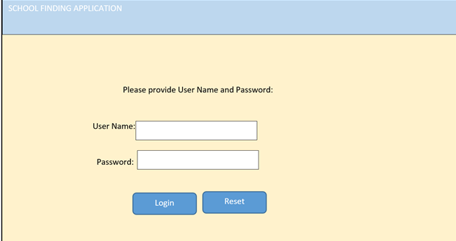

**Task 6:**

If the login user is a dmin, then the following sample screen will appear :

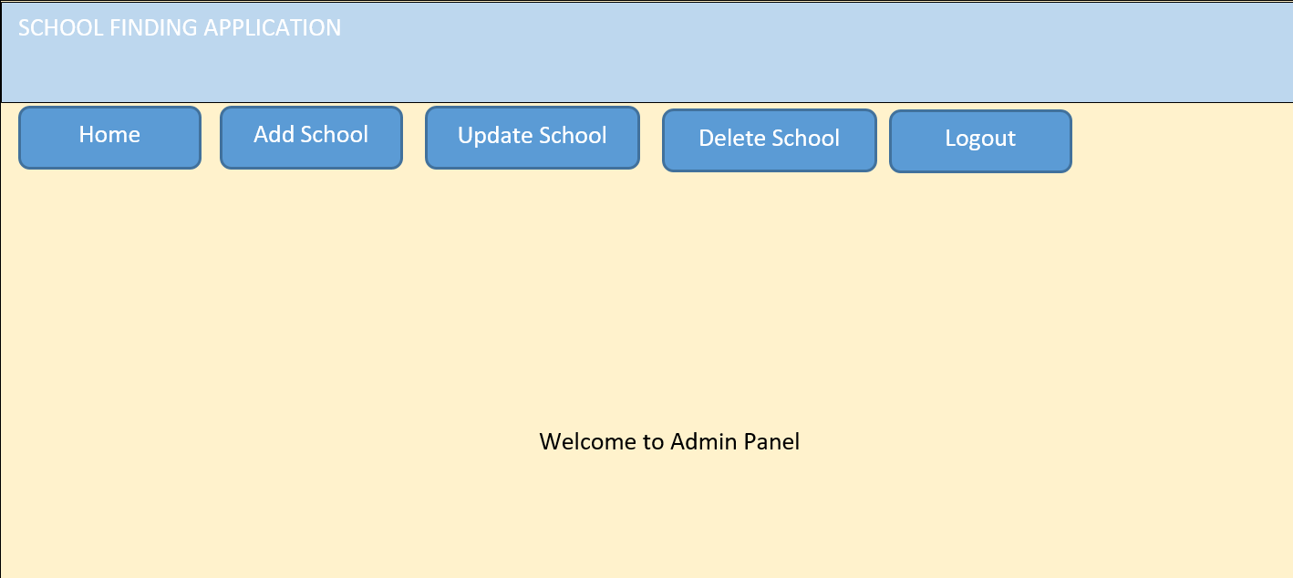

**Task 7**

The admin will click the “Add School” link/button to add the School.

You have to design the interface for the “Add School” as per the following sample:

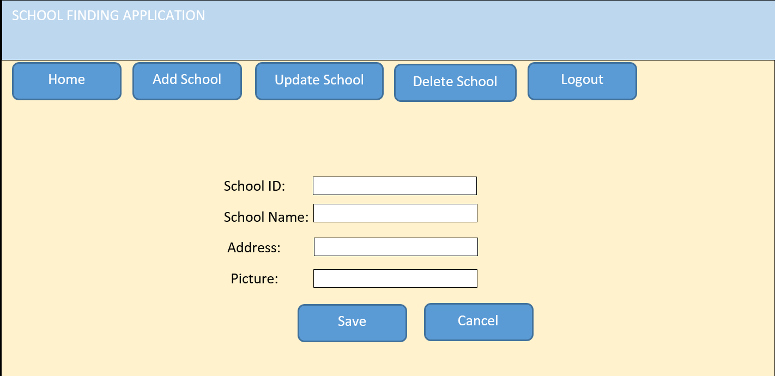

**Task 8**

Admin can update the School by click the “Update School” link/tab. The sample interface is given below:

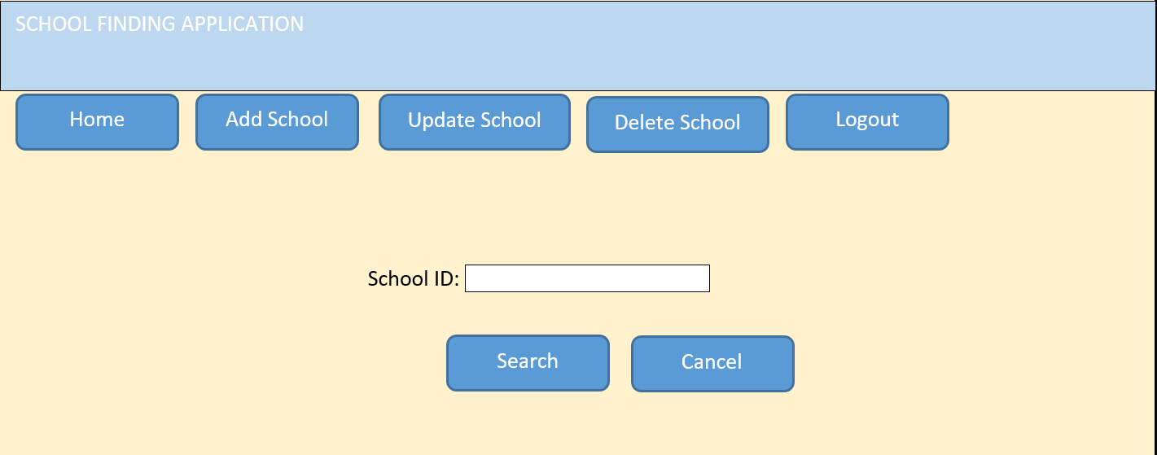

**Task 9:**

After entering the School ID, the admin click the “Search” button, if the record exists, then that record will be displayed. The admin update the required field and click on the “Update” button, as a result the record will be updated. The sample page may appear as:

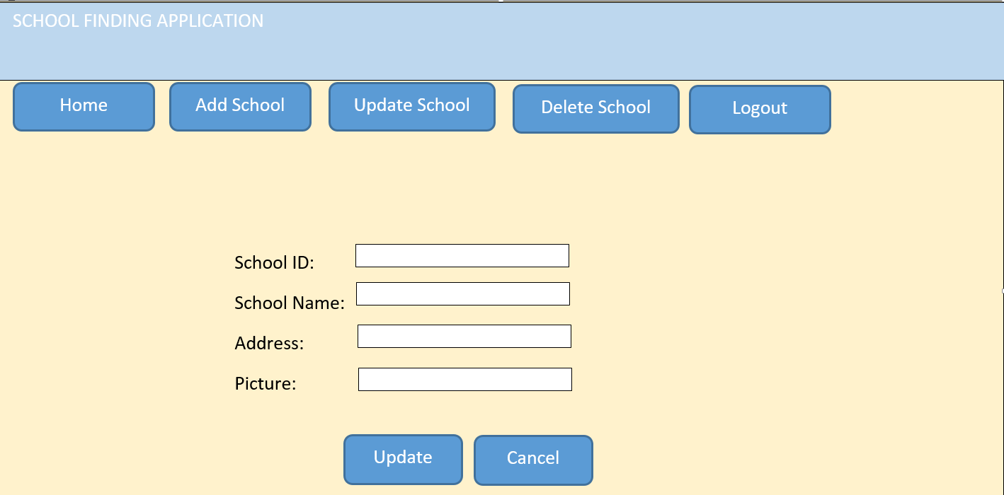

**Task 10**

Admin can delete the School information by clicking the “Delete School” link/tab. The sample interface is given below:

The admin first enter the School ID and then click the “Search” button, if the record exists, then that record will be displayed. Then admin will click the “Delete” button, to delete a specific record. If the record not exist, then appropriate message should be display.

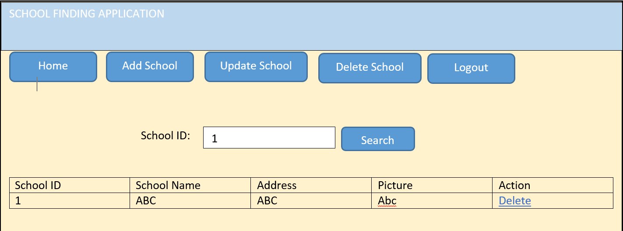

**Task 11**

When user click on the “Signup” button, then the following interface apper:

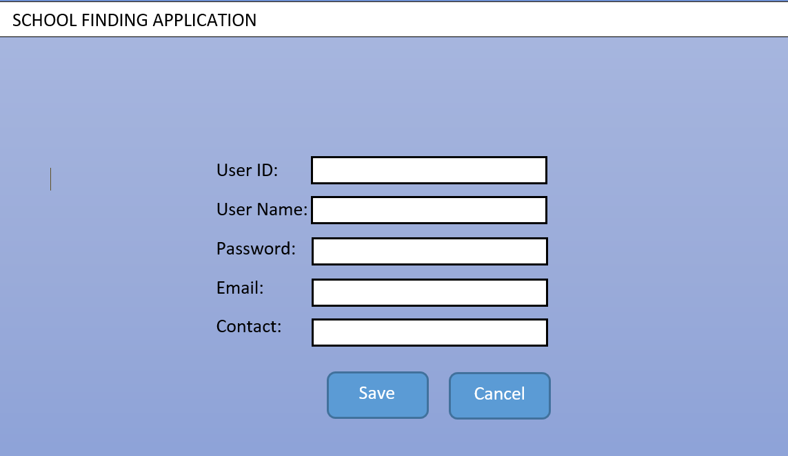

**Task 12**

After the Sign Up, the user click Login button/tab. Provide the valid user name and password and then login to the system. The interface may be looks like:

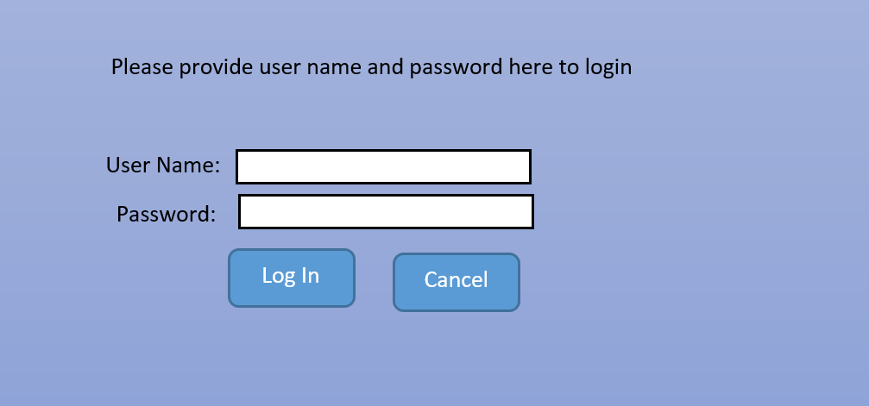

**Task 13**

After the login, user can view all the School Information. The interface may be looks like:

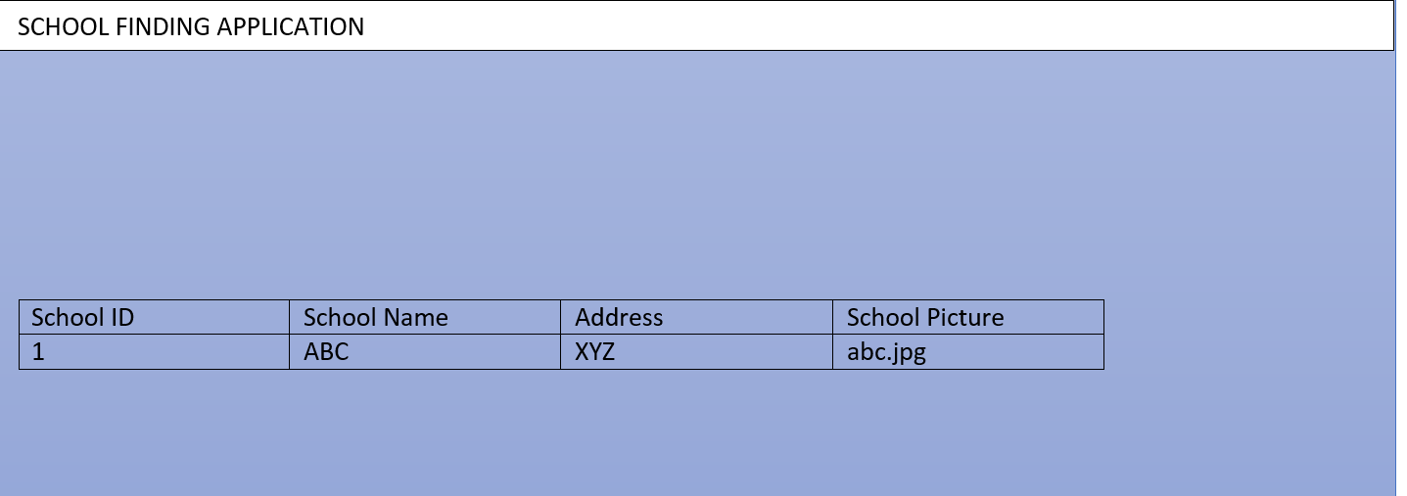

**Note:**

**You are required to submit the complete code (source code + database file+ any other file necessary for application running) in a zip or Winrar format.**

**The layout of the website may be different from the provided sample layout, but the functionality must be identical.**

**You can modify the interfaces as per your convience.**